河海大学

中国政府奖学金年审用户操作手册
Annual Review Manual for
Chinese Government Scholarship
Students in
Hohai University

Part One:学生使用部分 For students

一、进入网上办事大厅操作 Log on the Internet Page
1、登录河海大学信息门户http://myhall.hhu.edu.cn，首先进入办事大厅界面；
Log on http://myhall.hhu.edu.cn, enter interface of the Hall of Students Affairs.
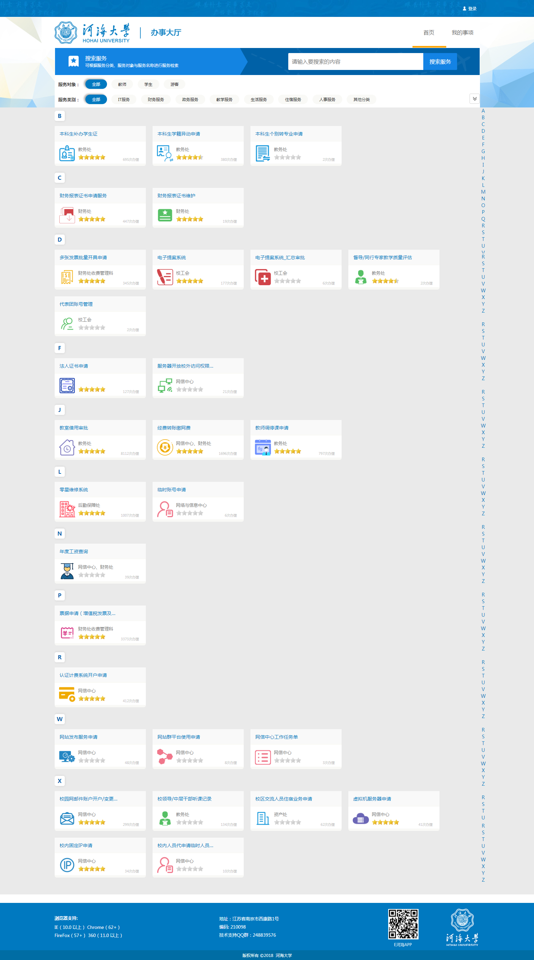
图 1

- 点击【登录】按钮，填写账号密码登录(和HHU Daily Health Report一致)，进入首页
Click on the <Log on> button, fill in the account and password (the same as HHU Daily Health Report), and you will enter the main page.
图 2

- 您可以选择服务对象→学生&服务类型→教务服务选择需要办理的业务Annual Review of Chinese Government Scholarship即可操作进行。
You may choose the service object→ student & service types→ choose the “Annual Review of Chinese Government Scholarship”，the operation will continue.
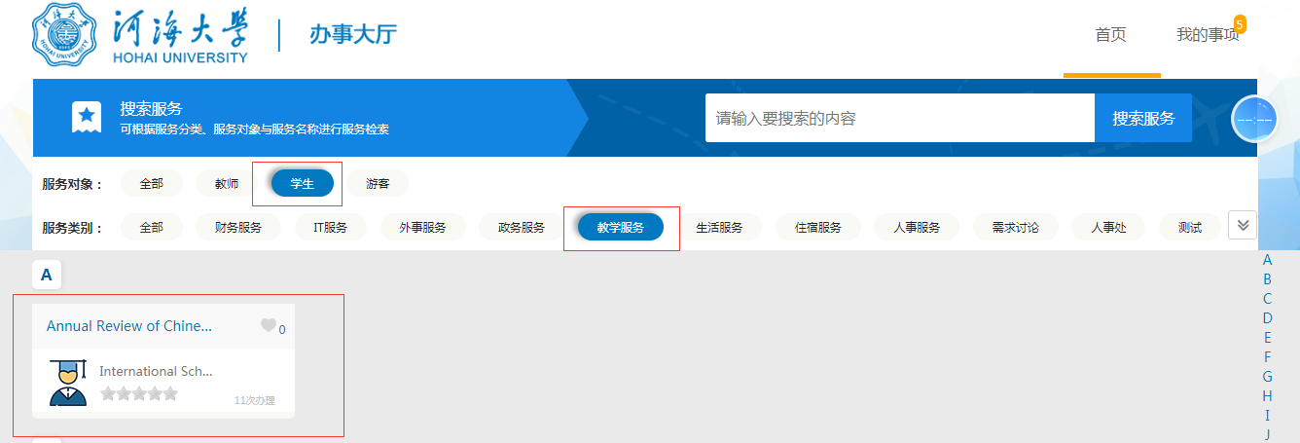
图3

- 您也可以在搜索框里通过搜索流程名称：Annual Review of Chinese Government Scholarship来快速定位需要申请的流程
You may input“ Annual Review of Chinese Government Scholarship”in the search box, and locate your application process.
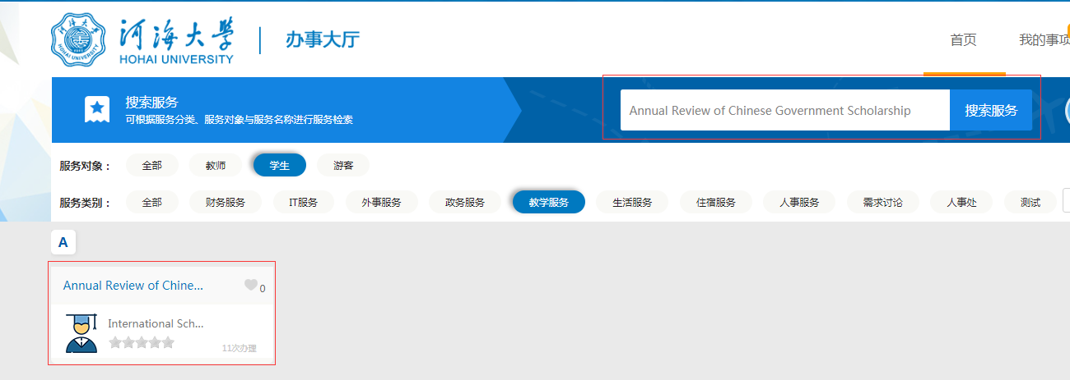
图4

- 点击标签的流程名称后，看到当前页面，填写完成后，点击【提交Submit】即提交成功，请立即通知你的导师（研究生）或者学院教学秘书（本科生）审批。
Click the designated button, and fill in your personal information in the page, click the <Submit>button, and then you should inform your supervisors (Master) or Bachelor Teaching Secretary for review.
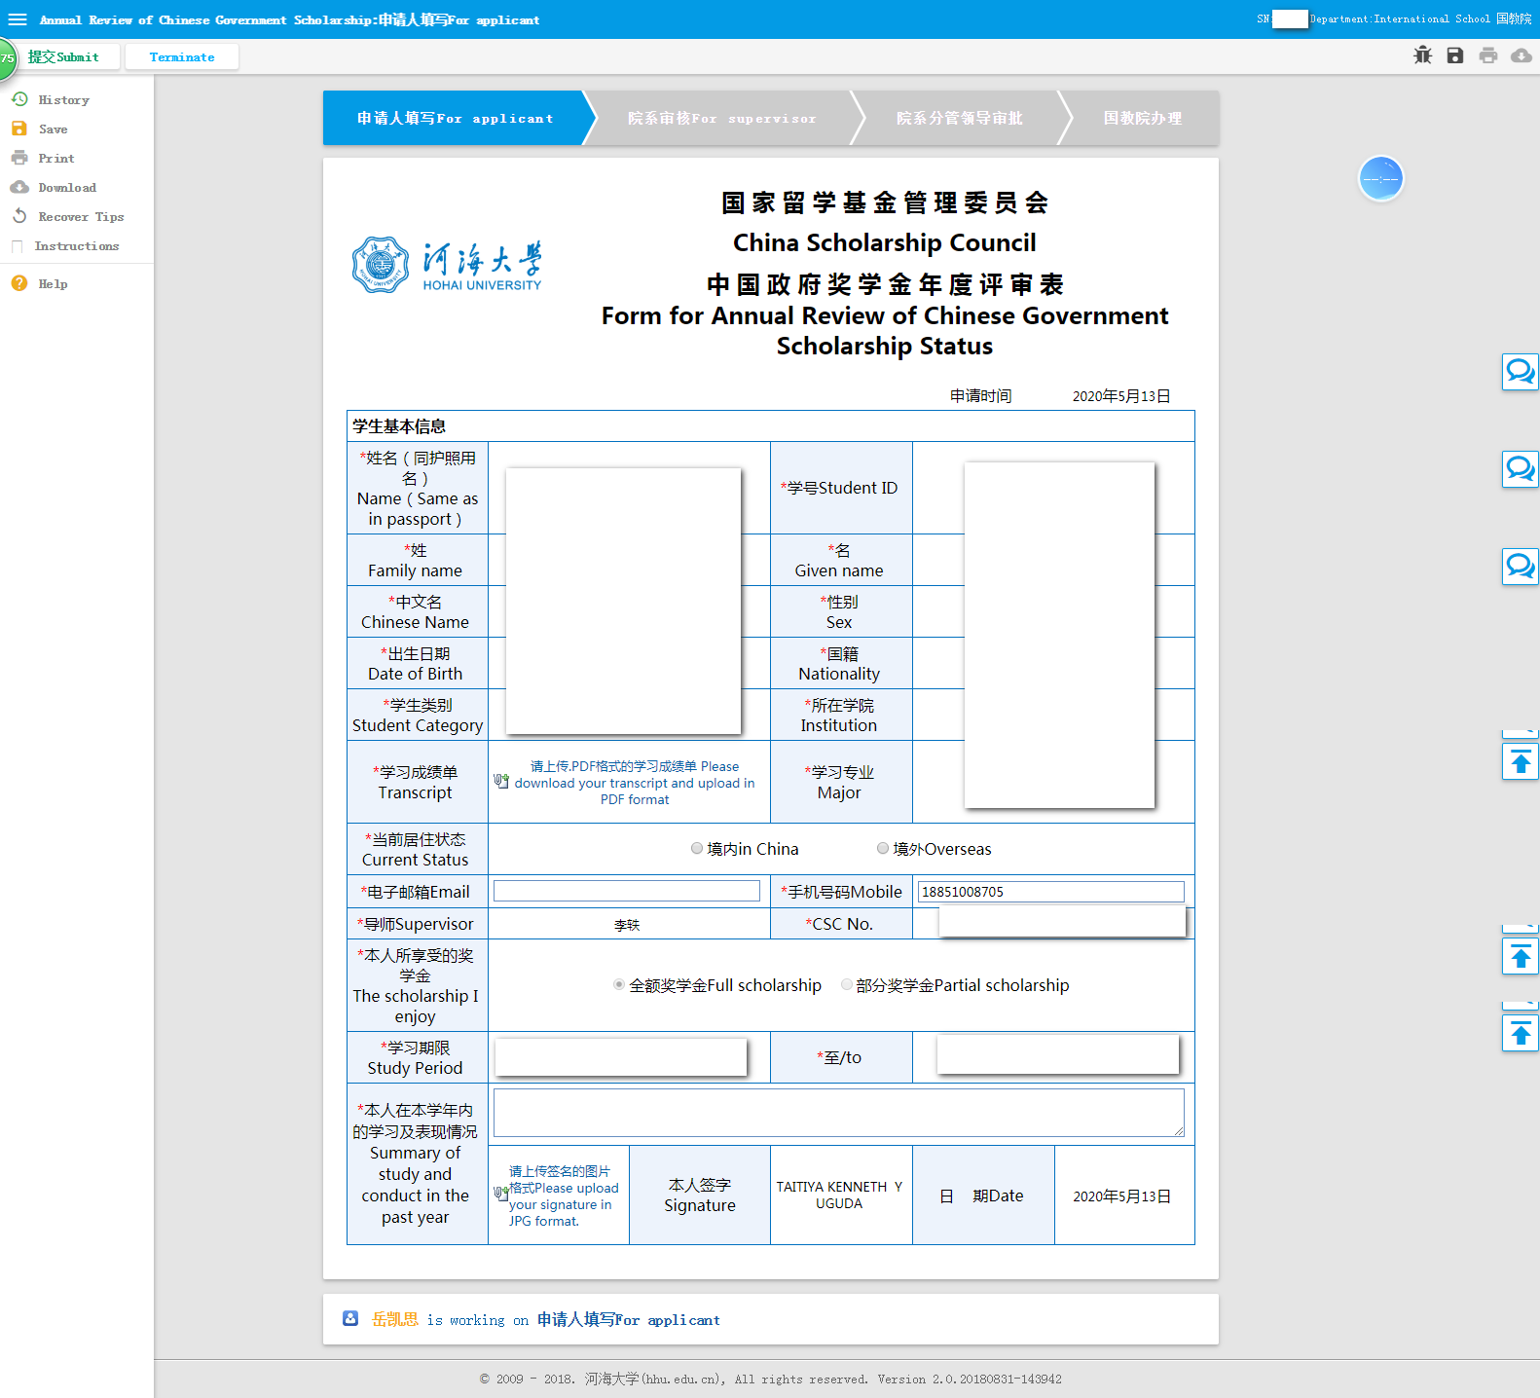
图 5

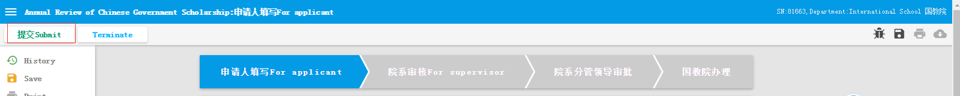
图6

Part Two:老师使用指南 For teachers
1、登录河海大学信息门户, 进入办事大厅界面
http://myhall.hhu.edu.cn
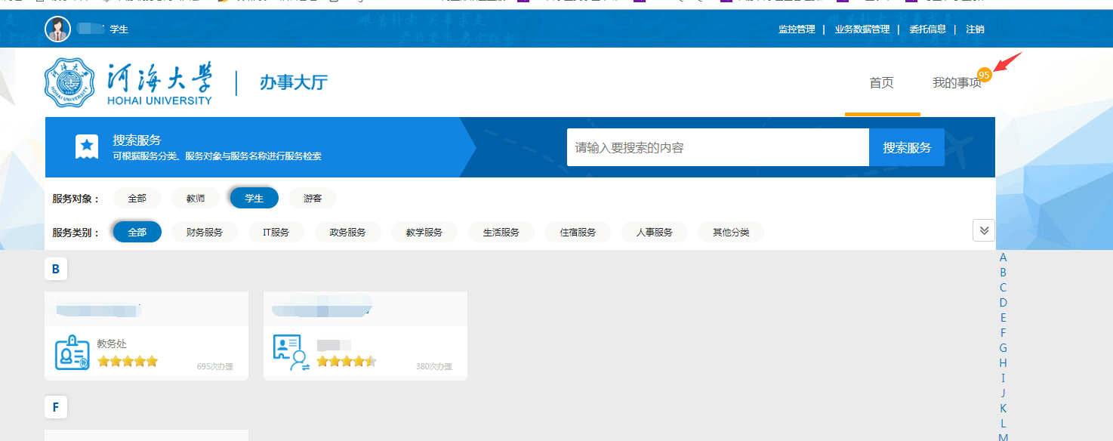
2、点击页面右上角的“我的事项”，在页面中间点击“需要我审批的事项”，进行业务办理。

